A DEEP LEARNING FRAMEWORK FOR SCALABLE, DISTRIBUTED, INCREMENTAL IMAGE CLASSIFICATION

A THESIS IN

Computer Science

Presented to the Faculty of the University

Of Missouri-Kansas City in partial fulfillment

Of the requirements for the degree

MASTER OF SCIENCE

By

MANIKANTA MADDULA

B.Tech, Amrita Vishwa Vidyapeetham – Coimbatore, India, 2013

Kansas City, Missouri

2017

©2017

MANIKANTA MADDULA

ALL RIGHTS RESERVED

A DEEP LEARNING FRAMEWORK FOR SCALABLE, DISTRIBUTED, INCREMENTAL IMAGE CLASSIFICATION

Manikanta Maddula, Candidate for the Master of Science Degree

University of Missouri-Kansas City, 2017

ABSTRACT

Machine Learning powers many aspects of modern society: object identification in images, speech to text, language translation, recommendation systems, e-commerce, drug discovery, genomics etc. and have its presence in all types of consumer products. Deep Learning is a new area of Machine Learning research, which has been introduced with the objective of moving Machine Learning closer to one of its original goals: Artificial Intelligence. Current research and practice of Deep Learning do not fully support some important features such as incremental learning, distributed learning to extent that is required.

The objective of this thesis is to provide a solution to this problem by building a framework that is scalable, distributed and incremental in nature. The presented approach focuses mainly on image classification problem, but can be applied to any supervised machine Learning problem. In the proposed solution, overall learning problem is divided into two stages, Local Learning and Global Learning.

In local learning, supervised learning problem is divided into heterogenous groups of smaller problem sizes, for e.g. classification problem of 100 different classes is divided into smaller classification problem sizes. These smaller problems are solved using optimized original solution for better local performance.

The predictions or activations from local learning are input to global learning in solving overall problem. Depending on the type of problem, global learning is solved using feed forward deep neural network. The proposed solution is implemented in Tensorflow, an open source software library for machine learning developed by Google with the capability of building and training deep neural networks using parallel GPU computations. To support the effectiveness of framework, we have evaluated the architecture on image classification on datasets like MNIST, CIFAR100 and using Softmax regression and Convolutional Neural Networks. Evaluation confirms that presented framework is a significant approach for building scalable, distributed, and incremental machine learning models.

APPROVAL PAGE

The faculty listed below, appointed by the Dean of the School of Computing and Engineering, have examined a thesis titled “A Deep Learning Framework for Scalable, Distributed, Incremental Image Classification” presented by Manikanta Maddula, candidate for the Master of Science degree, and hereby certify that in their opinion, it is worthy of acceptance.

Supervisory Committee

Dr. Yugyung Lee, Ph.D., Committee Co-Chair

School of Computing and Engineering

Dr. Zhu Li, Ph.D.

School of Computing and Engineering

Dr. Yongjie Zheng, Ph.D.

School of Computing and Engineering

TABLE OF CONTENTS

ABSTRACT iii

APPROVAL PAGE ……………………………………………………………………………………………………………………….……. v

ILLUSTRATIONS………………………………….................................................................................................viii

ACKNOWLEDGEMENTS ……………………………………………………………………………………………………………………. x

Chapter

1. INTRODUCTION 1

1.1 Motivation 1

1.2 Problem Statement 2

1.3 Proposed Solution 3

2. BACKGROUND AND RELATED WORK 5

2.1 Terminology & Technology 5

2.1.1 Machine Learning ..……………………………………………………………………………………………………. 5

2.1.2 Neural Networks ………....…………………………………………………………………………………………… 6

2.1.3 Convolutional Neural Networks ….……………………………………………………………………………..11

2.1.4 Model Training ……..…………………………………………………………………………………………………..16

2.2 Tensorflow 18

2.3 Related Work 21

3. IMPLEMENTATION 24

3.1 Overview 24

3.2 Local Learning 24

3.3 Global Learning ……..……………………………………………………………………………………………………………...30

4. RESULTS AND EVALUATION……………………………………………………………………………………….......... 35

4.1 Introduction 35

4.2 Implementation 35

4.3 Datasets 35

4.3.1 MNIST …………………..…………………………………………………………………………………………………..36

4.4 Evaluation 36

4.5 Summary 48

5. CONCLUSION AND FUTURE WORK 49

5.1 Conclusion 49

5.2 Limitations 49

5.3 Future Work 50

REFERENCES………………………………………………………………………………………………………………….…………….….51

VITA…………………………………………………………………………………………………………………………..……………….…..53

ILLUSTRATIONS

Figure Page

1: Cartoon Drawing of a Biological Neuron  7

2: Mathematical Model of Biological Neuron ..……………………………………………………………………………….. 7

3: Mathematical Model of Artificial Neuron  8

4: Different Activation Functions  9

5: Example Feed Forward Multi-Layer Perceptron 10

6: Illustration of a Spatial Pooling Operation 13

7: Architecture of LeNet-514

8: Illustration of the Architecture of AlexNet15

9: Convolution Decomposition in VGG15

10: Filter Size Reduced in GoogLeNet16

11: Tensorflow Architecture19

12: Example Tensorflow dataflow graph20

13: Examples from MNIST Dataset25

14: MNIST Image in Vector Format26

15: Example Architecture of SoftMax Regression27

16: Architecture of MNIST SoftMax Regression27

17: Architecture of MNIST Convolution Neural Network29

18: Overall Architecture for MNIST SoftMax Regression 33

19: Overall Architecture for MNIST Convolutional Network 34

20: Samples from MNIST Dataset 36

21: Local Model Confusion – MNIST SoftMax (0, 1, 2, 3, 4) 38

22: Local Model Confusion – MNIST SoftMax (5, 6, 7, 8, 9)39

23: Local Model Confusion Table – MNIST SoftMax40

24: MNIST SoftMax Regression Learning Rate of Global Network41

25: Tensorflow Dataflow Graph for MNIST Softmax – Global Network42

26: MNIST SoftMax Regression Accuracy Comparison43

27: MNIST SoftMax Regression Time Comparison 43

28: MNIST SoftMax Regression Accuracy of Global Network44

29: MNIST SoftMax Regression Cross Entropy of Global Network44

30: MNIST SoftMax Regression Readout Layer Summaries of Global Network45

31: MNIST SoftMax Regression Hidden Layer1 Summaries of Global Network45

32: MNIST SoftMax Regression Hidden Layer2 Summaries of Global Network46

33: MNIST SoftMax Regression Readout Layer Distributions of Global Network46

34: MNIST SoftMax Regression Hidden Layer1 and 2 Distributions of Global Network47

35: MNIST SoftMax Regression Readout Layer Histograms of Global Network47

36: MNIST SoftMax Regression Hidden Layer1 and 2 Histograms of Global Network48

ACKNOWLEDGEMENTS

First and foremost, I would like to thank my advisor Dr. Yugyung Lee for all the innovative ideas, insights, advice and challenging deadlines that have helped me achieve this thesis. She has been a constant source of motivation and zeal, not only during my thesis but also during my entire Master program. She was always welcoming for all the help I needed throughout my work, it has always amazed me for the kind of support and inspiring suggestions she has given me for the development of this thesis.

Secondly, I would like to thank the University of Missouri-Kansas City, without which this research would not be possible. The school provided me with good opportunities to support myself and a Lab for my research on a GPU machine. I would also like to thank my lab mates for their generous support.

Finally, I would like to express my heartful gratitude to my family and friends for providing me with constant support and encouragement. This accomplishment would not be possible without them.

CHAPTER 1

### INTRODUCTION

* 1. **Motivation**

Machine learning is the science of getting computers to act without being explicitly programmed. It evolved from the study of pattern recognition and computational learning theory in artificial intelligence. Machine learning explores the study and construction of algorithms that can learn from and make predictions on data – such algorithms overcome following strictly static program instructions by making data driven predictions or decisions. Machine Learning algorithm is developed using a training data set and then make of this model to answer a question. For example, we can give lots of images of “cat” and “Dog” to build a model and then ask if a new image is cat or dog. Now a day’s machine learning is used for so many use cases, Computer Vision, Speech Recognition, Natural Language Processing, Language Translation, Data Security, Healthcare, Marketing, Recommendation systems, Smart search, Self-driving cars, Autonomous robots etc. It is so pervasive today that you probably use it dozens of times a day without knowing it. Many researchers also think it is the best way to make progress towards human-level AI.

The most powerful form of machine learning being used today, is called “deep learning”, builds a complex mathematical structure called a neural network based on vast quantities of data. Neural networks are designed to work analogous to how a human brain works. Neural networks were first described in 1930’s but only in the last three to four years, enough computational power has been achieved. But it takes a massive amount of computing performance to train the sophisticated deep neural networks that power these new applications. That’s a huge challenge. Training can take days to weeks on even the fastest supercomputers. There are lot of advancements in GPU computations recently. With GPU acceleration, neural net training is 10-20 times faster than with CPUs. That means training is reduced from days or even weeks to just hours. This lets researchers and data scientists build larger, more sophisticated neural nets, which leads to incredibly intelligent next-gen applications. NVIDIA GPUs and the Deep Learning SDK are driving advances in machine learning. The number of organizations developing and using GPU-accelerated deep learning frameworks to train deep neural networks is growing. As the number of applications is growing, the number of models used are also growing in more heterogenous manner. That is models with different applications need to combined and sometimes only part of some models might be needed. And data is growing enormously each day, currently ImageNet a hierarchical image database contains 14,197,122 images and growing each day. Because of this there is a need for more Scalable, Distributed learning, incremental, multi task able machine learning approach. This research presents one such approach which is scalable with distributed learning and incremental properties.

**1.2 Problem Statement**

Most of the machine learning algorithms, especially in deep learning try to solve a supervised classification problem whether it is computer vision or natural language processing. A supervised classification model tries to classify an input to one of the pre-labeled classes or categories. For example, classifying an image whether it is a “cat” or “dog”.

The model training can be distributed with current architectures, i.e. distributed computing is available with the existing libraries like Tensorflow, Caffe, Apache Spark etc. But it is not possible to do Distributed Learning or inference by following traditional model approaches. Using a complex deep network model for inference would need operations in range of millions. So, a model inference which can be distributed is required for better performance.

As the data grows, model needs to learn about this new data. For e.g. in recommendation and user behavior systems, model needs to update based on user preferences which change time-to-time. In traditional approaches, the complete end-to-end model needs to be retrained for new data. And the existing model needs to be replaced completely. And if we would like to add new class or category to the existing model, then the model needs to be completely redesigned and trained from scratch.

Complex models are being developed to increase the model’s predictive performance. These complex solutions often involve using multiple models, for example, audio and visual input for image classification. Such implementations need more distributed approaches. With advancements in machine learning algorithms, user expectation also grows and this leads to creating models which can perform multiple tasks for which we need to combine many of the existing machine learning algorithms.

**1.3 Proposed Solution**

This thesis presents a machine learning approach that is scalable, distributed and incremental in nature. The presented approach focuses mainly on image classification problem, but can be applied to any supervised machine Learning problem.

At a higher level of abstraction, the machine learning problem is divided into two parts hierarchically. In the first part of the learning, all the classes or categories are divided into smaller sets of heterogeneous groups. This group size can be in different ranges, but should be a minimum of two for classification problem. These smaller set of heterogenous is again a supervised classification problem, but with smaller number of classes. These smaller classification problems are solved using traditional machine learning algorithms. For example, image classification sub-problem can be solved using Convolutional Neural Networks. For the second part of the problem, predictions made by the smaller models is used as input to solve the overall prediction task. In the second part of problem, additional machine learning algorithms are used to solve the complete classification problem. Because of the less number of input dimensions for second part, and based on the number of groups, size of the groups and heterogeneity of these groups, the problem in second part can be complex enough but it won’t increase with different requirements and can be solved.

The approach makes use of SoftMax regression, Convolutional Neural Networks, Random Forest etc. machine learning techniques. And Tensorflow, open source software library for numerical computation and Machine Intelligence is used. Presented approach can be extended to solve for all supervised problems like Natural Language Processing, Language Translation, speech recognition etc.

CHAPTER 2

### BACKGROUND AND RELATED WORK

In this chapter, we will define the terms that have been used throughout the paper and introduce the technologies. We will also discuss the related works to the presented solution and problem statement.

**2.1 Terminology and Technology**

**2.1.1 Machine Learning**

Machine learning is a science that gives computers the ability to learn without being explicitly programmed. Evolved from the study of pattern recognition and computational learning theory in artificial intelligence, machine learning explores the study and construction of algorithms that can learn from and make predictions on data – such algorithms overcome following strictly static program instructions by making data driven predictions or decisions, through building a model from sample inputs. Machine learning is employed in a range of computing tasks where designing and programming explicit algorithms with good performance is difficult or infeasible.

Formal definition:

A computer program is said to learn from experience E with respect to some class of tasks T and performance measure P, if its performance at tasks in T, as measured by P, improves with experience E. Machine learning tasks are typically classified into three broad categories, depending on the nature of the learning "signal" or "feedback" available to a learning system.

Supervised Learning: Supervised learning is a type of machine learning algorithm that uses a known dataset (called the training dataset) to make predictions. The training dataset includes input data and response values. From it, the supervised learning algorithm seeks to build a model that can make predictions of the response values for a new dataset. A test dataset is often used to validate the model. Using larger training datasets often yield models with higher predictive power that can generalize well for new datasets.

Supervised learning includes two categories of algorithms:

* Classification: for categorical response values, where the data can be separated into specific “classes”
* Regression: for continuous-response values

Unsupervised Learning: Unsupervised learning is a type of machine learning algorithm used to draw inferences from datasets consisting of input data without labeled responses. The most common unsupervised learning method is cluster analysis, which is used for exploratory data analysis to find hidden patterns or grouping in data. The clusters are modeled using a measure of similarity which is defined upon metrics such as Euclidean or probabilistic distance.

Reinforcement learning: A computer program interacts with a dynamic environment in which it must perform a certain goal (such as driving a vehicle or playing a game against an opponent. The program is provided feedback in terms of rewards and punishments as it navigates its problem space.

**2.1.2 Neural Networks**

The study of artificial neural networks (ANNs) has been inspired in part by the observation that biological learning systems are built of very complex webs of interconnected neurons (Figure1 and Figure2). In rough analogy, artificial neural networks are built out of a densely interconnected set of simple units, where each unit takes several real-valued inputs (possibly the outputs of other units) and produces a single real-valued output (which may become the input to many other units). The human brain, for example, is estimated to contain a densely interconnected network of approximately 1011 neurons, each connected, on average, to 104 others. Neuron activity is typically excited or inhibited through connections to other neurons. While ANNs are loosely motivated by biological neural systems, there are many complexities to biological neural systems that are not modeled by ANNs, and many features of the ANNs we discuss here are known to be inconsistent with biological systems.



Figure 1: Cartoon Drawing of a Biological Neuron



Figure 2: Mathematical Model of Biological Neuron

ANN system is based on a unit called a perceptron (Figure 3). A perceptron is an artificial neuron. A perceptron takes a vector of real-valued inputs, calculates a linear combination of these inputs, then outputs a 1 if the result is greater than some threshold and -1 otherwise.

Output= $\left\{\begin{aligned}0 if \sum_{j}{w_{j}x_{j}≤threshold} \\ 1 if \sum_{j}{w_{j}x_{j}>threshold} \end{aligned}\right.$

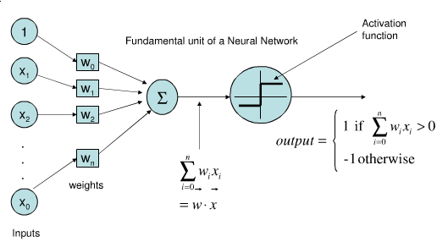

Figure 3: Mathematical Model of Artificial Neuron

This function is called “activation function”. There are different types of activation functions.

Sigmoid: The Sigmoid non-linearity has the following mathematical form

$$y= σ\left(x\right)=\frac{1}{1 + \exp^{-x}}$$

It takes a real value and squashes it between 0 and 1. However, when the neuron's activation saturates at either tail of 0 or 1, the gradient at these regions is almost zero.

Hyperbolic Tangent: The TanH non-linearity has the following mathematical form

$$y=2σ\left(2x\right)-1$$

It squashes a real-valued number between -1 and 1.

Rectified Linear Unit: The ReLU has the following mathematical form

$$y=max⁡(0,x)$$

The ReLU has become very popular in the last few years, because it was found to greatly accelerate the convergence compared to the sigmoid/tanh functions due to its linear non-saturating form. In fact, it does not suffer from the vanishing or exploding gradient. Another advantage is that it involves cheap operations compared to the expensive exponentials. However, the ReLU removes all the negative information and thus appears not suited for all datasets and architectures.

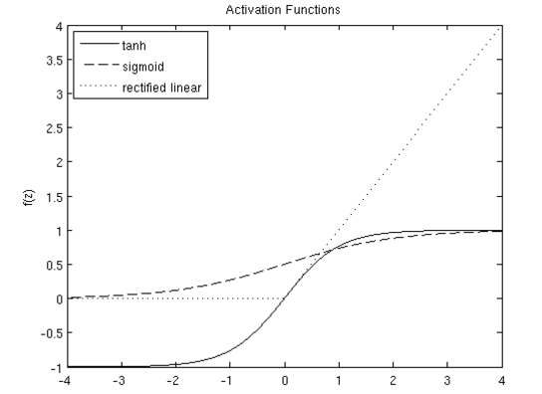

Figure 4: Different Activation Functions

Logistic Regression: It measures the relationship between the categorical dependent variable and one or more independent variables by estimating probabilities using a logistic function, which is the cumulative logistic distribution. It classifies to only two classes i.e. binary classification. A sigmoid neuron can be used to make a logistic regression model since it exactly models a logistic regression problem.

SoftMax Regression: Softmax regression (or multinomial logistic regression) is a generalization of logistic regression to the case where we want to handle multiple classes. In logistic regression we assumed that the labels were binary. Softmax regression allows us to handle K number of classes. Instead of one sigmoid neuron we would have to use K number of Sigmoid neurons.

Multilayer Perceptron: A neural network is put together by hooking together many of our simple “neurons,” so that the output of a neuron can be the input of another. A multilayer perceptron (MLP) is a feedforward artificial neural network model that maps sets of input data onto a set of appropriate outputs. An MLP consists of multiple layers of nodes in a directed graph, with each layer fully connected to the next one. Except for the input nodes, each node is a neuron (or processing element) with a nonlinear activation function. MLP utilizes a supervised learning technique called backpropagation for training the network. MLP is a modification of the standard linear perceptron and can distinguish data that are not linearly separable. It is called feed forward because as we proceed in the network, output of one layer is given as input to the next layer and there are no cycles.

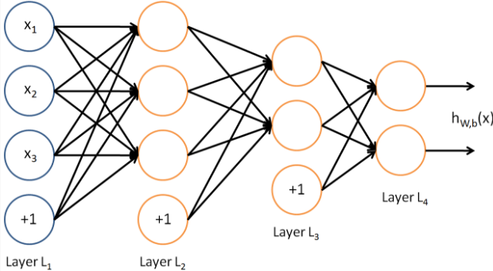

Figure 5: Example Feed Forward Multi-Layer Perceptron

The leftmost layer of the network is called the input layer, and the rightmost layer the output layer (which, in this example, has only one node). The middle layer of nodes is called the hidden layer, because its values are not observed in the training set. Example neural network (Figure 5) has 3 input units (not counting the bias unit), 3 hidden units, and 1 output unit.

Using forward step progress, feed forward network can be built as follows:

$$a_{1}^{ \left(2\right)}=f\left(W_{11}^{\left(1\right)}x_{1}+W_{12}^{\left(1\right)}x_{2}+W_{13}^{\left(1\right)}x_{3}+b_{1}^{\left(1\right)}\right)$$

$$a_{2}^{ (2)}=f(W_{21}^{\left(1\right)}x_{1}+W_{22}^{\left(1\right)}x_{2}+W_{23}^{\left(1\right)}x_{3}+b_{2}^{\left(1\right)})$$

$$a_{3}^{ (2)}=f(W_{31}^{\left(1\right)}x_{1}+W_{32}^{\left(1\right)}x_{2}+W_{33}^{\left(1\right)}x_{3}+b_{3}^{\left(1\right)})$$

$$h_{W,b }\left(x\right)=a_{1}^{(3)}=f(W_{11}^{\left(2\right)}a_{1}^{\left(2\right)}+W_{12}^{\left(2\right)}a_{2}^{\left(2\right)}+W_{13}^{\left(2\right)}a_{3}^{\left(2\right)}+b_{1}^{\left(2\right)}$$

Feed forward outputs:

$$z^{\left(2\right)}=W^{\left(1\right)}x+b^{\left(1\right)}$$

$$a^{\left(2\right)}={f(z}^{\left(2\right)})$$

$$z^{\left(3\right)}=W^{\left(2\right)}a^{\left(2\right)}+b^{\left(2\right)}$$

$$h_{W,b }\left(x\right)=a_{ }^{(3)}{f(z}^{\left(3\right)})$$

**2.1.3 Convolutional Neural networks**

Spatial Convolution: Regular Neural Networks (Multilayer Perceptron), only made of linear and activation layers, do not scale well to full images. For instance, images of size 3 × 224 × 224 (3 color channels, 224 wide, 224 high) would necessitate a first linear layer having 3 * 224 * 224 + 1 = 150; 129 parameters for a single neuron (e.g. output). Spatial convolution layers take advantage of the fact that their input (e.g. images or feature maps) exhibits many spatial relationships. In fact, neighboring pixels should not be affected by their location within image. Thus, a convolutional layer learns a set of Nk filters F = f1, …, fNk, which are convolved spatially with input image x, to produce a set of Nk 2D features maps z:

Zk = fk * x

where * is the convolution operator. When the filter correlates well with a region of the input image, the response in the corresponding feature map location is strong. Unlike conventional linear layer, weights are shared over the entire image reducing the number of parameters per response and equivariance is learned (i.e. an object shifted in the input image will simply shift the corresponding responses in a similar way). Also, a fully connected layer be a convolutional layer with filter of sizes *1* x *1* x *inputSize*. It is important to highlight that a spatial convolution is not defined by the spatial size of the input feature maps (e.g. wide and high), neither by the size of the output feature maps, but by the number of filters (e.g. number of output channels), the properties of its Filters (e.g. number of input channels, wide, high) and the properties of the convolution (e.g. padding, stride).

Spatial Pooling: In Convolutional Neural Networks, a pooling layer is typically present to provide invariance to slightly different input images and to reduce the dimension of the feature maps (e.g. wide, high):

pR = Pi∈R (zi)

where P is a pooling function over the region of pixels R. Max pooling is preferred as it avoids cancellation of negative elements and prevents blurring of the activations and gradients throughout the network since the gradient is placed in a single location during backpropagation.

The spatial pooling layer is defined by its aggregation function, the high and width dimensions of the area where it is applied, and the properties of the convolution (e.g. padding, stride).



Figure 6: Illustration of a Spatial Pooling Operation in 2 x 2 regions by a stride of 2 in the high direction, and 2 in the width direction, without padding.

Batch Normalization: This layer quickly became very popular mostly because it helps to converge faster. It adds a normalization step (shifting inputs to zero-mean and unit variance) to make the inputs of each trainable layers comparable across features. By doing this it ensures a high learning rate while keeping the network learning. Also it allows activations functions such as TanH and Sigmoid to not get stuck in the saturation mode (e.g. gradient equal to 0).

Many convolution architectures have been developed from 1990’s, we will present few of them.

LeNet: This kind of architecture is one of the first successful applications of CNNs. It was developed by Yann LeCun in the 1990's and was used to read zip codes and digits. This architecture, about the modern ones, differs on many points. Thus, we will limit ourselves on the most known, LeNet-5 [11], and we will not delve into the details. In overall this network was the origin of much of the recent architectures, and a true inspiration for many people in the field. LeNet-5 features can be summarized as:

* sequence of 3 layers: convolution, pooling, non-linearity,
* inputs are normalized using mean and standard deviation to accelerate training,
* sparse connection matrix between layers to avoid large computational cost
* hyperbolic tangent or sigmoid as non-linearity function,
* trainable average pooling as pooling function,
* fully connected layers as final classifier,
* mean squared error as loss function.



Figure 7: Architecture of LeNet-5, an Old Convolutional Neural Network for Digits’ Recognition.

AlexNet: It is one of the first work that popularized convolutional networks in computer vision. AlexNet was submitted to the ImageNet ILSVRC challenge of 2012 and significantly outperformed the other hand crafted models (accuracy top5 of 84% compared to the second runner-up with 74%). This network, compared to LeNet, was deeper (60 million of parameters) and bigger (5 convolutional layers, 3 max pooling and 3 fully-connected layers). At this implementation, the authors provided a multi-GPUs implementation in CUDA to bypass the memory needs. It popularized:

* the ReLU as non-linearity function of choice,
* the method of stacking convolutional layers plus non-linearity on top of each other without being immediately followed by a pooling layer,
* the method of overlapping Max Pooling, avoiding the averaging effects of Average Pooling.



Figure 8: An illustration of the Architecture of AlexNet. One GPU runs the layer-parts at the top of the figure while the others run the layer-parts at the bottom.

VeryDeep or VggNet: It was the runner-up architecture of ILSVRC2014 with almost 140 million of parameters. Its main contributions were to show that depth is a critical component for good performance, to use much smaller 3 x 3 filters in each convolutional layer, and to combine them as a sequence of convolutions. The great advantage of VggNet was the insight that multiple 3 x 3 convolution in sequence can emulate the effect of larger receptive fields, for examples 5 x 5 and 7 x 7. These ideas will be also used in more recent network architectures as Inception and ResNet.



Figure 9: Filter of 5 x 5 or more can be decomposed with multiple 3 x 3 convolutions such as in VGG.

GoogLeNet or Inception: It was the winner architecture of ILSVRC2014. Its main contribution was the development of an Inception Module that dramatically reduced the number of parameters (40 millions). Also, it eliminated many parameters by using average pooling instead of fully connected layers at the top of the convolutional layers. Further versions of the GoogLeNet has been released. The most recent architecture available is InceptionV3. Notably, it uses batch normalization.

Figure 10: 1 x 1 Convolutions are used to decrease the input size before 3 x 3 convolutions to provide more combinational power such as in GoogLeNet.

**2.1.4 Model Training**

Initialization: Initialize weights with a small amount of noise for symmetry breaking, and to prevent 0 gradients. Since we're using ReLU neurons, it is also good practice to initialize them with a slightly positive initial bias to avoid "dead neurons"

Loss Function: To quantify the capacity of the network to approximate the ground truth labels for all training inputs, we define a loss function which takes as inputs the weights, biases, and examples from the training set. For instance, the loss could be the number of images correctly classified. However, the most efficient way to find the weights and biases, regarding the number of parameters, is to use an algorithm like the Stochastic Gradient Descent (SGD). To do so, if our chosen loss function is not smooth, we must choose a surrogate loss (e.g. derivable function) such as Mean Square Error or Cross Entropy.

Backpropagation: For each example, we compute the prediction and its associated loss. We sum up all the loss to compute the final error. Then we use the backpropagation algorithm to propagate the error to compute the partial derivatives

$$\frac{δE}{δw} and \frac{δE}{δb}$$

of the cost function E for all weights w and bias b. In this work, our goal is not to explain in details how works the backpropagation algorithm. We advise the curious reader to read the chapter 2 of Michael Nielsen's book [27].

Optimization: Once all the derivatives are computed, we update our parameters using a chosen optimization technique such as SGD. We then iterate the predication (e.g. forward pass), the backpropagation of errors (e.g. backward pass) and the optimization until convergence hopping to find a local minimum low enough to ensure good predictions. Even if the chosen surrogate loss function of a neural network is non-convex, SGD works well in practice. There are many other optimization techniques available: Momentum, Nesterov accelerated gradient, Adagrad, Adadelta, RMSProp, Adam (Adaptive Moment Estimation). In this research, we used several of these based-on requirements to achieve faster and good convergence.

Grid Search: It is common to explore manually the space of hyperparameters such as learning rate, weight decay, learning rate decay, amount of dropout, not to mention the architecture hyperparameters, to obtain the best performance in terms of both accuracy and training time. [26] made an evaluation on the influence of architecture choices and optimization hyperparameters on ImageNet. While there are very few theoretical studies, technical studies of this kind can help the reader to reduce the space of hyperparameters to explore. Most of the current research implementations used grid search to find appropriate hyperparameters.

Regularization: Deep and large enough neural networks can memorize any data. During training, their accuracy on the trainset typically converges towards perfection while it degrades on the test set. This phenomenon is called overfitting. To reduce this a range of regularization techniques can be used. L2 Regularization, data augmentation, dropout, drop connect, early stopping. For most of the current implementations we used Dropout.

Dropout: The idea is to randomly set a certain percentage of the activations in each layer to 0. During the training, neurons must learn better representations without co-adapting to each other being active. At each training step in a mini-batch, the dropout procedure creates a different network (by randomly removing some units), which is trained using backpropagation as usual. The effect of this is that neurons are prevented from co-adapting too much which makes overfitting less likely. At test case the whole network is used (all units) but with scaled down weights. Mathematically this approximates ensemble averaging (using the geometric mean as average). It can also be said as a form of ensemble learning.

**2.2 Tensorflow**

TensorFlow is an open source software library for numerical computation using data flow graphs. Nodes in the graph represent mathematical operations, while the graph edges represent the multidimensional data arrays (tensors) communicated between them. The flexible architecture allows you to deploy computation to one or more CPUs or GPUs in a desktop, server, or mobile device with a single API. TensorFlow was originally developed by researchers and engineers working on the Google Brain Team within Google's Machine Intelligence research organization for the purposes of conducting machine learning and deep neural networks research, but the system is general enough to be applicable in a wide variety of other domains as well.

Architecture: TensorFlow is designed for large-scale distributed training and inference, but it is also flexible enough to support experimentation with new machine learning models and system-level optimizations. The TensorFlow runtime is a cross-platform library. Figure 11, illustrates its general architecture. Tensorflow has a layered architecture. A C API separates user level code in different languages from the core runtime. Kernel implementations are on top of Networking and Device layer. Master and Dataflow executor are above kernel implementations. Tensorflow gets its parameter server architecture from DistBelief.

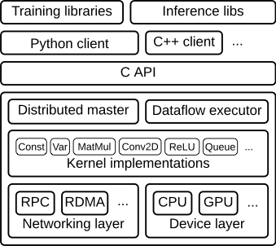

Figure 11: Tensorflow Architecture

Data flow graph describes the mathematical computation with a directed graph of nodes and edges.

* Nodes in the graph represent mathematical operations
* Edges describe the i/o relationships between nodes
* Data edges carry dynamically-sized multidimensional data arrays, or tensors

The flow of tensors is where TensorFlow gets its name. Nodes are assigned to computational devices and execute asynchronously and in parallel once all the tensors on their incoming edges become available.

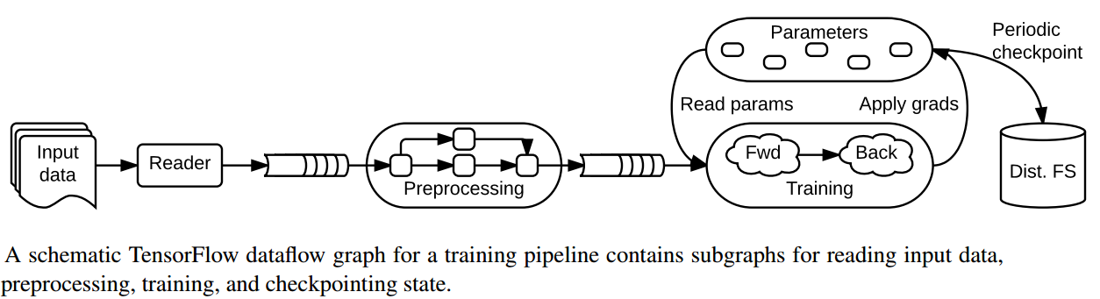

Figure 12: Example Tensorflow dataflow graph

Computation Graph: TensorFlow programs are usually structured into a construction phase, that assembles a graph, and an execution phase that uses a session to execute ops in the graph. For example, it is common to create a graph to represent and train a neural network in the construction phase, and then repeatedly execute a set of training ops in the graph in the execution phase. TensorFlow can be used from C, C++, and Python programs. It is presently much easier to use the Python library to assemble graphs, as it provides a large set of helper functions not available in the C and C++ libraries. The TensorFlow Python library has a default graph to which ops constructors add nodes. The default graph is sufficient for many applications. Tensorflow allows interactive run, that is it allows to move execution between python or client and back end.

Tensors: TensorFlow programs use a tensor data structure to represent all data -- only tensors are passed between operations in the computation graph. You can think of a TensorFlow tensor as an n-dimensional array or list. A tensor has a static type, a rank, and a shape.

Variables: Variables maintain state across executions of the graph.

TensorBoard: The computations you'll use TensorFlow for - like training a massive deep neural network - can be complex and confusing. To make it easier to understand, debug, and optimize programs, TensorFlow included a suite of visualization tools called TensorBoard. You can use TensorBoard to visualize your TensorFlow graph, plot quantitative metrics about the execution of your graph, and show additional data like images that pass through it. The data displayed with TensorBoard module are generated during the execution of TensorFlow and stored in trace files whose data are obtained from the summary operations.

GPU Usage: Because of the more number of cores and higher parallelism, using GPU accelerates the Deep Learning Routines. Deep Learning Networks, Convolutional Networks most used operations are Matrix, vector multiplications, convolutions, and other small set. GPU can be used to accelerate these operations to reduce training time. NVIDIA Deep Learning SDK provides powerful tools and libraries for designing and deploying GPU accelerated deep learning applications. It contains many libraries and tools like cuDNN, GIE, CUDA toolkit etc. cuDNN provides highly tuned implementations for standard routines such as forward and backward convolution, pooling, normalization, and activation layers. GPU Inference Engine (GIE) optimizes your trained neural networks for runtime performance. Deep Learning GPU Training System (DIGITS) helps in designing the best deep neural network (DNN) for image classification and object detection tasks using real-time network behavior visualization.

**2.3 Related Work**

This research focuses on building multiple heterogenous models and combining their predictions in another model. So, the easiest comparison one would make with this approach is ensemble learning. There are three most used ensembles learning methods are Bagging, Boosting and Voting. Bagging is to Build multiple models (typically of the same type) from different subsamples of the training dataset. Boosting is to build multiple models (typically of the same type) each of which learns to fix the prediction errors of a prior model in the chain. Voting is to build multiple models (typically of differing types) and simple statistics (like calculating the mean) are used to combine predictions. All these approaches build many models most of the time for all the classes with different subset of data. But our approach is to build smaller models with heterogenous classes and then combine their prediction.

[17] discusses a Multi-Level discriminative dictionary learning with application to large scale image classification. In this paper, they incorporated the discrimination of classification task into dictionary learning. Sparse local features (like SIFT features) are used as input to build dictionary. The input signal (e.g., image or patch) is represented as a sparse linear combination of the bases in a dictionary. It takes take advantage of category hierarchy for discriminative dictionary learning. The set of class labels is organized as a hierarchical structure (e.g., tree). The root node at the top layer contains all the classes. Each internal node (i.e., non-leaf node), as a hyper-category, is associated with a set of related classes. Each leaf node corresponds to a single class. The hierarchy can be built upon the semantic correlation or visual similarity among categories. Thus, the structure reflects the hierarchical correlation among categories. Category hierarchy displays diversified inter-correlation among the sibling nodes at different layers. The siblings at higher layers are less related, thus the discrimination among them is much easier. Given the hierarchy, each internal node is associated with a discriminative dictionary and a classification model that discriminates its child nodes. Each node at lower layers also inherits the dictionary of its parent, so that the categories at lower layers can be described with sufficient discriminative information at multiple scales. The ensemble of dictionaries and classification models are jointly learnt by optimizing an overall tree loss. There are a lot of differences between this and our presented approach. Current approach uses only two levels how large the number of categories are. Our approach can be said as bottom-up hierarchy to make the final predictions this is where our approach is similar to this approach, we are using hierarchy to improve model properties in terms of scalability, distributed learning and inference and incremental learning. Start with smaller heterogenous models and then go to next part of model which makes final predictions based on predictions from smaller model. And we are not using any dictionaries and sparse features. We are using pixel data as input features. In our approach, local models are trained with individual losses and second part of model is trained with another loss function.

David H. Wolpert introduced stacked generalization, a scheme for minimizing the generalization error rate of one or more generalizers. Stacked generalization works by deducing the biases of the generalizer(s) with respect to a provided learning set. This deduction proceeds by generalizing in a second space whose inputs are (for example) the guesses of the original generalizers when taught with part of the learning set and trying to guess the rest of it, and whose output is (for example) the correct guess. When used with multiple generalizers, stacked generalization can be seen as a more sophisticated version of cross-validation, exploiting a strategy more sophisticated than cross-validation’s crude winner-takes-all for combining the individual generalizers. When used with a single generalizer, stacked generalization is a scheme for estimating (and then correcting for) the error of a generalizer which has been trained on a particular learning set and then asked a particular question. Unlike bagging and boosting, stacking may be (and normally is) used to combine models of different types. The procedure is as follows: Split the training set into two disjoint sets. Train several base learners on the first part. Test the base learners on the second part. Using the predictions from 3) as the inputs, and the correct responses as the outputs, train a higher level learner. Note that steps 1) to 3) are the same as cross-validation, but instead of using a winner-takes-all approach, we combine the base learners, possibly nonlinearly. By far this approach is very similar to what we are doing but in stacked generalization each base learner is modelled on all the classes and in our approach, we build several smaller models on heterogenous groups. This makes our approach significantly different in terms of end-to-end system.

CHAPTER 3

### IMPLEMENTATION

**3.1 Overview**

The proposed solution works for any type of supervised learning problem, we will implement the architecture for Image Classification. The overall architecture is presented in Figure. The supervised learning problem is divided into two stages, Local Learning and Global Learning. As a classification problem, we will have a set of classes, these are divided into some smaller heterogenous groups. That is classification problem is divided into sub problems. Local Learning is to solve these sub problems using traditional approaches i.e. a feed-forward network or a convolutional neural network. As we would be solving small number categories in each sub problem the number of parameters that are need will be less and name these as local models. Once the local learning is completed, we will make use of the predictions of local models as input for the global learning. Global learning problem is to give the overall prediction based on the predictions made by local models. For this problem, another neural network is built, the size and complexity of this network will be based on the overall problem complexity, in this case the number of classes in the overall classification problem. For the problem of Image Classification, a fully connected feed-forward network will be required. The number of hidden layers varies based on number of classes. Additional tuning on this global neural network model need to be done for better performance.

**3.2 Local Learning**

Overall classification problem is divided into smaller problems and these smaller problems are solved using a neural network similar to original solution with small problem size. The size of the smaller problem and number of smaller groups are decided based on our future needs like how small the sub-problem needs to be and how often new classes are added to the model, how often new data is added, how sparse the new data to be added is etc. For e.g. if the overall classification problem has 10 classes, then we can divide it in to 5 sub-problems of two classes or 2 sub-problems of 5 classes in each or several other combinations. Choose these based-on future requirements to support incremental, distributed nature with minimal computational expenses. Select the sub-problem size and group size based on following:

* How frequent new classes are added.
* How frequent new data is added to existing classes.
* How sparse the new data will be. Out of all the available classes, for how many classes does new data is updated.

For solving the sub-problems, use less lesser number of parameters, make each local model less complex than the existing model for overall problem. A less complex model should be enough to solve the sub-problem and the accuracy and performance of local problem would be better because of the smaller problem size.

Consider the classification of MNIST computer vision dataset. It consists of hand written images of numbers 0 to 9.



Figure 13: Examples from MNIST Dataset

The MNIST data is split into three parts: 55,000 data points of training data, 10,000 points of test data, and 5,000 points of validation data. Every MNIST data point has two parts: an image of a handwritten digit and a corresponding label. We'll call the images "x" and the labels "y". Both the training set and test set contain images and their corresponding labels; for example the training images are mnist.train.images and the training labels are mnist.train.labels. Each image is 28 pixels by 28 pixels. We can interpret this as a big array of numbers as shown in Figure 14.

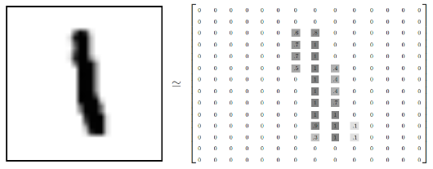

Figure 14: MNIST Image in Vector Format

We can flatten this array into a vector of 28x28 = 784 numbers. It doesn't matter how we flatten the array, as long as we're consistent between images. From this perspective, the MNIST images are just a bunch of points in a 784-dimensional vector space. The result is that mnist.train.images is a tensor (an n-dimensional array) with a shape of [55000, 784]. The first dimension is an index into the list of images and the second dimension is the index for each pixel in each image. Each entry in the tensor is a pixel intensity between 0 and 1, for a particular pixel in a particular image.

We're going to want our labels as "one-hot vectors". A one-hot vector is a vector which is 0 in most dimensions, and 1 in a single dimension. In this case, the nth digit will be represented as a vector which is 1 in the nth dimension. For example, 3 would be [0,0,0,1,0,0,0,0,0,0]. Consequently, mnist.train.labels is a [55000, 10] array of floats.

Consider solving this problem using simple Softmax Regression As shown in Figure 15 (shows a Softmax regression for 3 inputs and 3 outputs) and Figure 16 (784 input neurons and 10 output neurons). So, when we try to solve this, our weight variable will be of shape [784,10] (since 10 output neurons for 10 classes) and bias variable of shape [10]. And then we define a loss function, say cross entropy and update our weights and biases using an optimizer (like gradient descent) to reduce this loss.

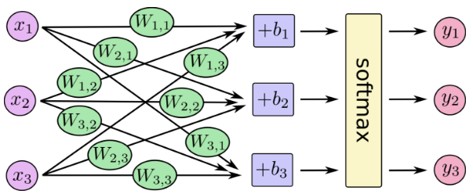

Figure 15: Example Architecture of SoftMax Regression

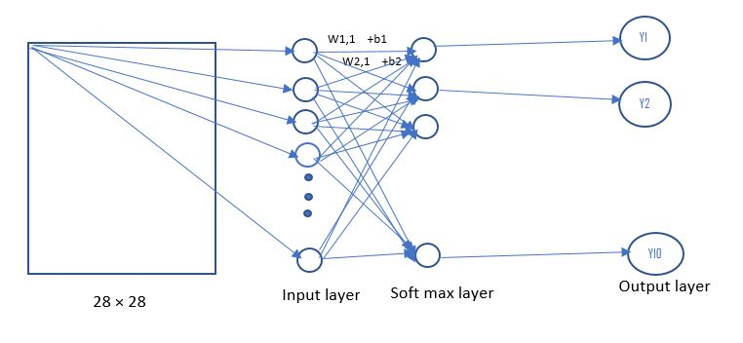

Figure 16: Architecture of MNIST SoftMax Regression

And if we want to solve the same MNIST classification problem using our approach, we would want to design sub-problem size and number of groups (i.e. group size). So, say 2 classes in each sub-problem, then there will 5 such groups. These heterogenous groups can be as [(0,1), (2,3), (4,5), (6,7), (8,9)]. There are several other combinations, these heterogenous groups can be selected based on the confusion matrix from original model. Say we designed the heterogenous groups as [(0,1), (2,3), (4,5), (6,7), (8,9)], then for each sub-problem we would need a weight variable of shape [784,2] and bias variable of shape [2] with the Softmax regression. And since there are only 2 classes in each sub-problem higher accuracy can be achieved with less number of iterations than that is required in original model. So, local learning is to solve sub-problem with same approach as original solution of the problem with optimal number of parameters and performance.

This MNIST classification problem can also be solved using Convolutional neural network to achieve higher accuracy because using convolutional neural network we can make use of the spatial features in images. Let us look at the sample design of original CNN model for MNIST classification problem.

* Each convolutional layer contains one convolution and max pooling.
* Convolutional layers, one densely connected layer, one dropout layer, read out layer
* First convolution layer contains 32 features for each 5x5 patch. So, weight variable is of shape [5, 5, 1, 32] and bias variable of shape [32] with [1,1,1,1] strides and for pooling ksize=[1, 2, 2, 1], strides=[1, 2, 2, 1].
* Second convolution layer contains 64 features for each 5x5 patch, so, weight variable is of shape [5, 5, 32, 64] and bias variable of shape [64] with [1,1,1,1] strides and for pooling ksize=[1, 2, 2, 1], strides=[1, 2, 2, 1].
* Densely connected layer will have weight variable of shape [7*7*64,1024] and bias variable of shape [1024].
* Readout layer will have weights of shape [1024, 10] and biases of shape [10]

Then we define a loss like cross entropy, use an optimization algorithm to update parameters reducing loss and increasing accuracy. This original solution is presented in Figure 17.

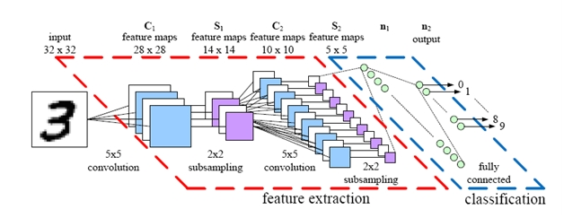

Figure 17: Architecture of MNIST Convolution Neural Network

If we want to solve the same MNIST classification problem using our approach, we would want to design sub-problem size and number of groups (i.e. group size). Say we designed the heterogenous groups as [(0,1), (2,3), (4,5), (6,7), (8,9)], then each sub-problem can be solved as follows:

• Each convolutional layer contains one convolution and max pooling.

• 2 Convolutional layers, one densely connected layer, one dropout layer, read out layer

• First convolution layer contains 6 features for each 5x5 patch. So, weight variable is of shape [5, 5, 1, 6] and bias variable of shape [6] with [1,1,1,1] strides and for pooling ksize=[1, 2, 2, 1], strides=[1, 2, 2, 1].

• Second convolution layer contains 12 features for each 5x5 patch, so, weight variable is of shape [5, 5, 6, 12] and bias variable of shape [12] with [1,1,1,1] strides and for pooling ksize=[1, 2, 2, 1], strides=[1, 2, 2, 1].

• Densely connected layer will have weight variable of shape [7 * 7 * 12, 100] and bias variable of shape [100].

• Readout layer will have weights of shape [1000, 10] and biases of shape [10]

The design of local models is made such that the total parameters are in the same range as original model i.e., there is no increase in number of parameters for local models and the number of iterations required to solve sub-problems will be lesser than the original solution and the accuracy of local models would be high. And this approach can be extended to any type of supervised learning problem and this approach can be extended to join different local model problems i.e., say image classification and text classification, or image and speech classifier etc. to solve a multi-task model problem. And this is scalable because the number parameters, time to computation is similar. And because of this we can include distributed and incremental learning properties in our approach.

**3.3 Global Learning**

Global learning tries to solve the overall classification or prediction problem based on inputs from local model.

Data Preprocessing: Input to global model comes from local models. We would have to combine the results from all the local models. And we should do other pre-processing on input data like batch preparation, queue preparation etc. so that it is ready to be provided to global model. In our approach, we send local model predictions as input to global model. So, for all the available training data, compute local predictions first. For this we would have to load all local models and compute local model predictions. And prepare queue of this data for global model so that it won’t wait for input data. For the global learning, we could send in the final layer activations as input instead of simple Softmax predictions for higher performance of global model. And if we want to join different kinds of local models, then the data preprocessing would include proper vector transformations required based-on the type models being joined. Labels for global model would be same as for overall problem. Most of the scenario’s the preprocessing would include following:

• Load local models.

• Compute local model predictions or required local model activations.

• Combine the local model responses into single input vectors

• Create functions to generate batch data and fill queues with data

Local Model Confusion:

Local models are trained to classify for sub-problems, but for global model we need compute predictions of local models for all classes data and local model may not able to always classify one particular class data into one of the trained classes. For e.g. a local model trained to classify between (0,1) may be able to classify all 3’s to one of the pre-trained labels 0 or 1. This is called local models confusion, the local models can be tuned to make this confusion less. Local models groups can be selected to make this confusion less.

Global Model:

Once the data (labeled data) is ready for the global model, we need to design global learning network. Number of dimensions in input data will be same as number classes in the classification problem. For e.g. MNIST classification problem will have input feature vectors of size [10] and dimensionally speaking this is a good thing, but the problem of predicting the overall classification task is complex. But we have another advantage here, how big or complex the local models are global network complexity is not depended on that but just the number of classes in overall classification problem. Global network can be designed based-on the overall problem at hand. For image classification, with local model predictions as input, we can build a multi-layer feed forward neural network for global learning. For this feed forward neural network, we have to choose a lot of hyper parameters:

• Number of hidden layers

• Number of neurons in each hidden layer

• Initialization of weights and biases

• Learning rate function, starting learning rate

• Optimization Algorithm

• Number of iterations

• Type of regularization

For all the hyper parameters, we used a grid search to find the best parameters. Number of hidden layers were gradually increased until there is some minimum increase overall accuracy. Number of neurons in each hidden layer were kept same for all the hidden layers for simplicity, and it chosen to be an optimal value to control global model complexity. Weights were initialized with a standard deviation of 0.1 and mean 1, and biases were initialized randomly with mean 1 and standard deviation 1.

Learning rate: Different learning rate functions has been tried, Exponential decay, Inverse time decay, Polynomial function, natural exponential decay. And different starting learning rates were tried to achieve faster convergence of loss function. This is observed by visualizing in TensorBoard.

Optimization algorithms: We tried with all the available optimization algorithms in Tensorflow, Gradient Descent Optimizer, Adadelta Optimizer, Adagrad Optimizer, AdagradDA Optimizer, Momentum Optimizer, Adam Optimizer, Ftrl Optimizer, Proximal Gradient Descent Optimizer, Proximal Adagrad Optimizer, RMSProp Optimizer and the best results were reported in evaluation section. For the MNIST classification, the network would be like as shown in Figure 18 and Figure 19.

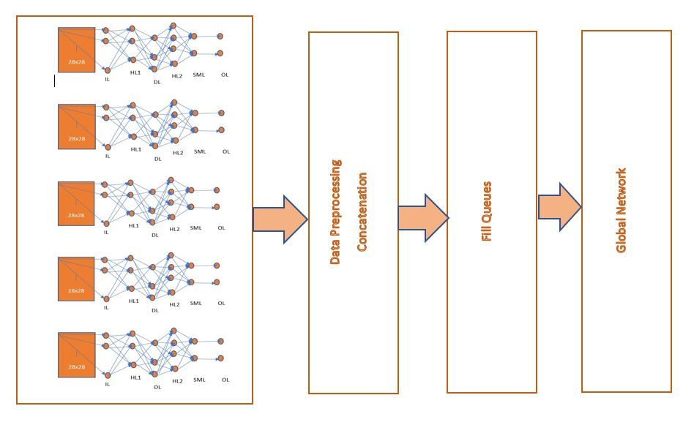

Figure 18: Overall Architecture for MNIST SoftMax Regression

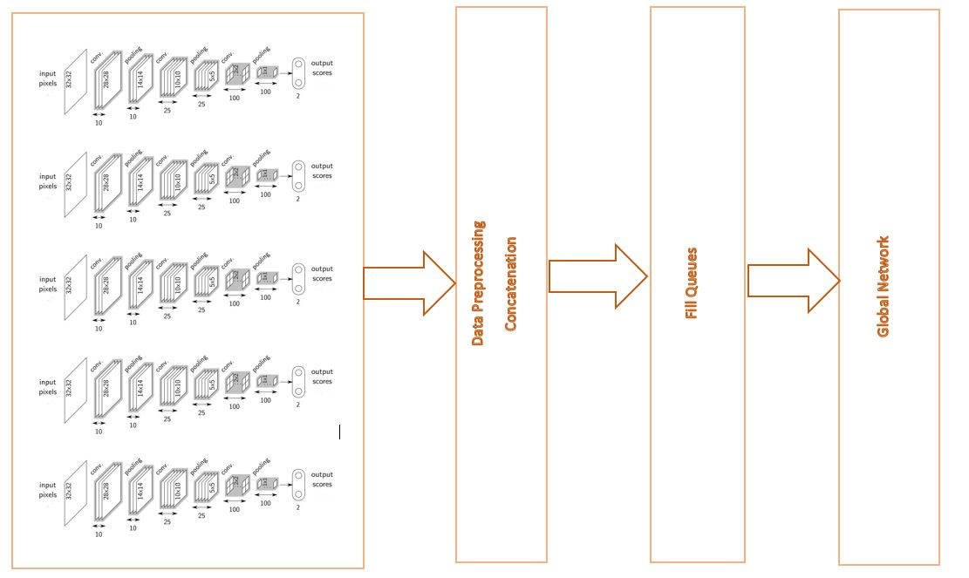

Figure 19: Overall Architecture for MNIST Convolutional Network

CHAPTER 4

### RESULTS AND EVALUATION

* 1. **Introduction**

**This chapter describes several sets of evaluations that were conducted using presented Framework. Implementation, System configurations will also be discussed. The experiments were designed to verify factors like training time taken by presented approach compared to existing state of art machine learning algorithms, number of parameters, the accuracy of presented approach and the state of art algorithms.**

**4.2 Implementation**

**Tensorflow framework is used to conduct all the experiments. System Configuration:**

* **Operating System: Ubuntu 14.04 LTS**
* **Memory: 31.3 GiB**
* **Processor: Intel® Xeon(R) CPU E5-2630 v4 @ 2.20GHz × 15**
* **Graphics: TITAN X (Pascal)/PCIe/SSE2 (12 GiB)**
* **OS Type: 64 bit**
* **Disk: 1.9TB**

**As we have tested the presented approach using Tensorflow, the objective of distributed computing and independent learning are already achieved.**

**4.3 Datasets**

**In this section, we will discuss different datasets that are used for Evaluation.**

**4.3.1 MNIST**

**The MNIST (Figure 20) consists of handwritten digits, has a training set of 60,000 examples, and a test set of 10,000 examples. It is a subset of a larger set available from NIST. The digits have been size-normalized and centered in a fixed-size image.**

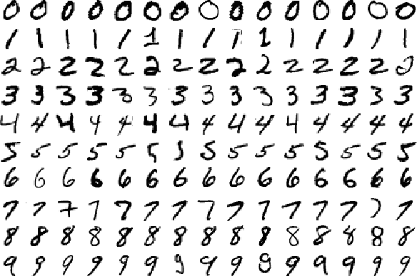

**Figure 20: Samples from MNIST Dataset**

* 1. **Evaluation**

**Different case studies were taken to observe the behavior of presented architecture.**

**Case 1: MNIST Softmax Regression**

**Original solution for MNIST classification is to use a layer of Softmax Regression on top of a single hidden layer. Input layer takes a vector of size [784] and produces 10 predictions, the probability of each class. The original model is presented in Figure 16. It used stochastic Gradient Descent Optimizer. For 10000 iterations with a batch size of 100 for each iteration. Original model gave a test accuracy of 92% and it took a time of** **58186 m secs.**

**Our Implementation:**

**Architecture is as in Figure 33.**

**Problem Sets: 2 sub problems, each with 5 classes, (0, 1, 2, 3, 4) and (5, 6, 7,8, 9).**

**Local Learning:**

**Local Model 1: (0, 1, 2, 3, 4)**

**Input layer takes a vector of size [784] and produces, [5] outputs. One Hidden layer and a Softmax layer to produce predictions as probability. Weights of shape [784,5] and biases of shape [5]. Truncated Normal initialization for weights and zero initialization for biases. Used Gradient Descent Optimizer with all data as input in each iteration for 800 iterations.**

**Time for training local network: 5496 m secs.**

**local model accuracy: 97.02%**

**Local model confusion: Each local model is trained on some of all the original classes but for the global network input, inference from all the classes is required. Here local model may classify untrained class data clearly into one of trained classes or not. This we term as local model confusion. For this local model, it is presented in Figure 21 and Figure 23.**

**Figure 21: Local Model Confusion – MNIST SoftMax (0, 1, 2, 3, 4)**

**Local Model 2: (5, 6, 7, 8, 9)**

**Input layer takes a vector of size [784] and produces, [5] outputs. One Hidden layer and a Softmax layer to produce predictions as probability. Weights of shape [784,5] and biases of shape [5]. Truncated Normal initialization for weights and zero initialization for biases. Used Gradient Descent Optimizer with all data as input in each iteration for 800 iterations.**

**Time for training local network: 4992 m secs.**

**local model accuracy: 93.42 %**

**Local model confusion: Each local model is trained on some of all the original classes but for the global network input, inference from all the classes is required. Here local model may classify untrained class data clearly into one of trained classes or not. This we term as local model confusion. For this local model, it is presented in Figure 22 and Figure 23.**

**Figure 22: Local Model Confusion – MNIST SoftMax (5, 6, 7, 8, 9)**



**Figure 23: Local Model Confusion Table – MNIST SoftMax**

**Global Learning:**

**For the global network (Figure 25), predictions from 2 local models are concatenated and used as input. Input is of shape [10]. Then 2 hidden layers with 100 neurons in each. A dropout layer and then a Readout layer. Truncated normal initialization for both weights and biases. Inverse time decay learning rate (Figure 25), RMSProp Optimizer. Batch size of 1000 images for each iteration. In the first 10000, iterations validation accuracy is 88.8% and then the increase in accuracy is very small due to inverse time decay learning rate.**

**Time for training global network: 214205 ms**

**global network accuracy: 88.90%**

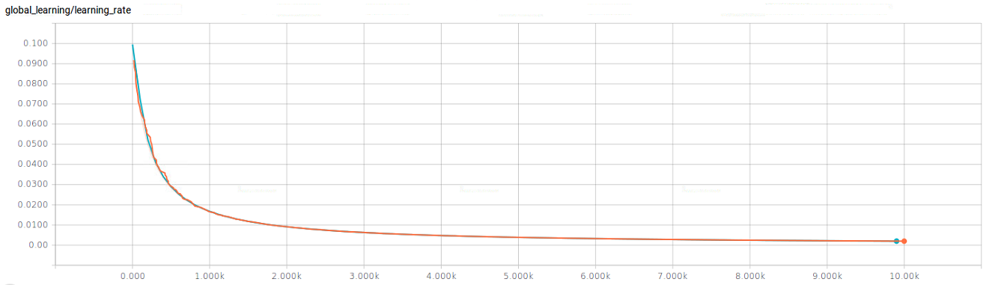

**Figure 24: MNIST SoftMax Regression Learning Rate of Global Network**

**Tensorflow dataflow graph for global network is shown in Figure. Global Network Accuracy and Cross Entropy is show in Figure 28 and Figure 29. Original solution and presented approach is compared in terms of accuracy and time in Figure 26 and Figure 27. Lot of summaries, histograms, activations, pre-activations are show in Figure 30 to 36 for Hidden Laer1, Hidden Layer2, and Readout layer of global Network.**

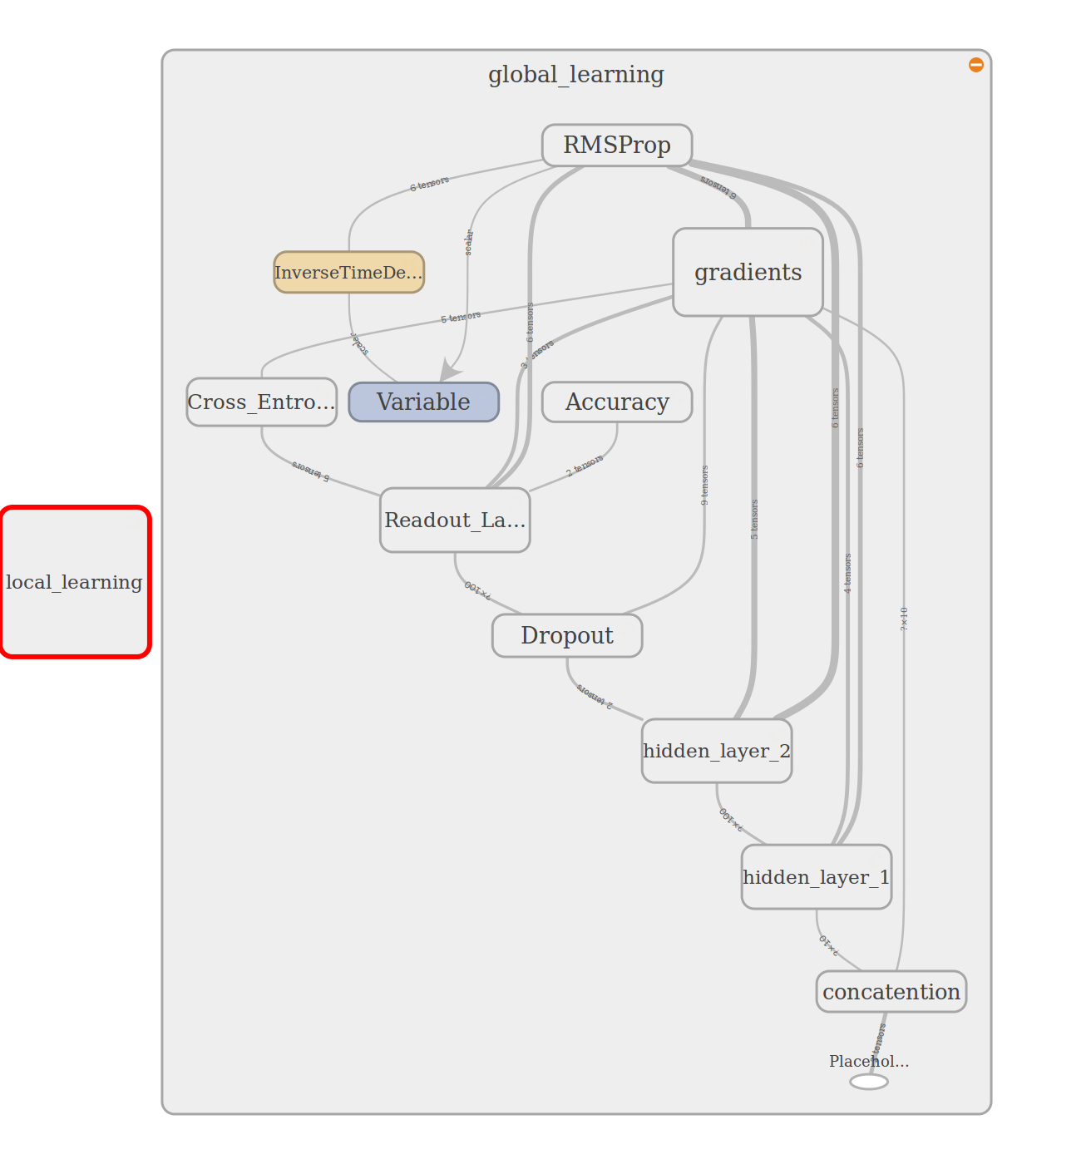

**Figure 25: Tensorflow Dataflow Graph for MNIST Softmax – Global Network**

**Figure 26: MNIST SoftMax Regression Accuracy Comparison**

**Figure 27: MNIST SoftMax Regression Time Comparison**

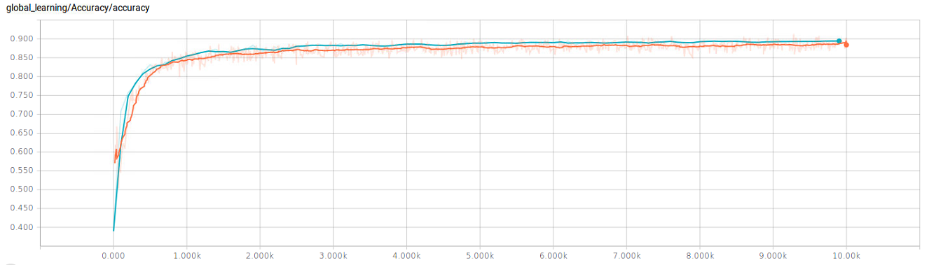

**Figure 28: MNIST SoftMax Regression Accuracy of Global Network**

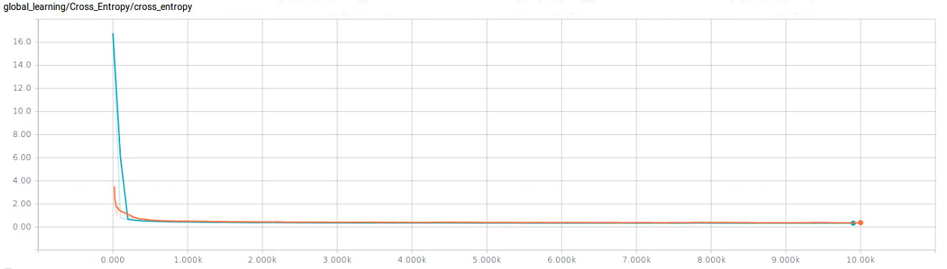

**Figure 29: MNIST SoftMax Regression Cross Entropy of Global Network**

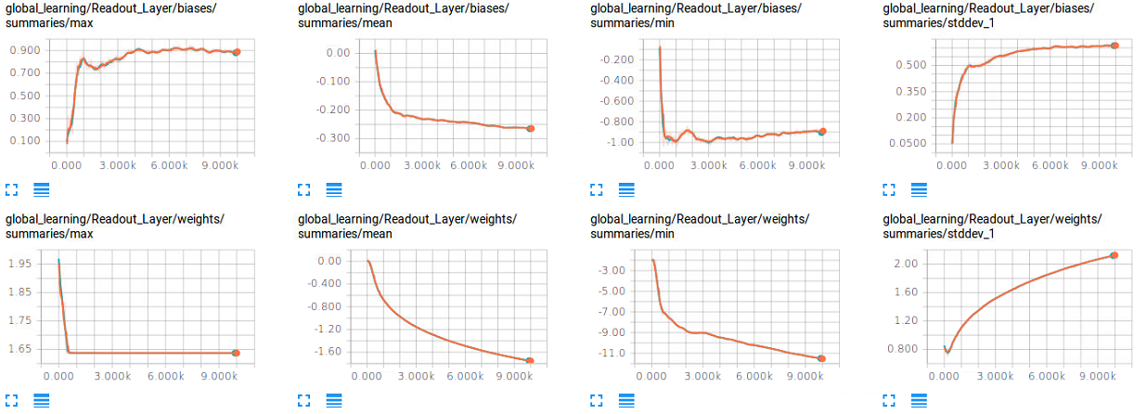

**Figure 30: MNIST SoftMax Regression Readout Layer Summaries of Global Network**

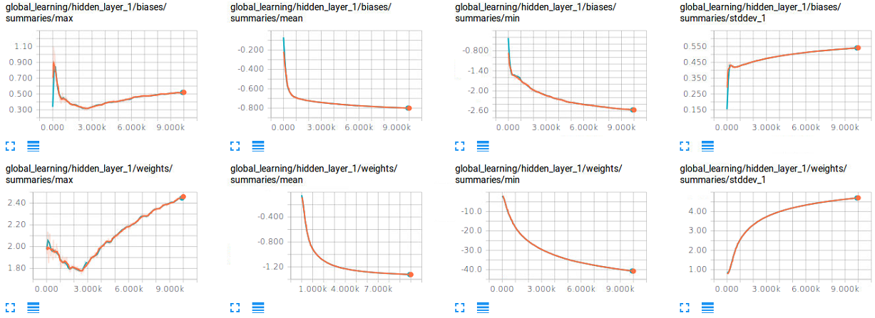

**Figure 31: MNIST SoftMax Regression Hidden Layer1 Summaries of Global Network**

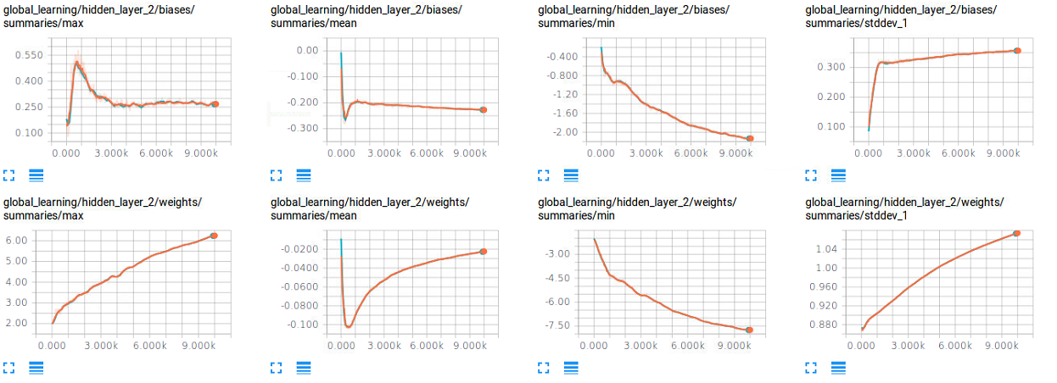

**Figure 32: MNIST SoftMax Regression Hidden Layer2 Summaries of Global Network**

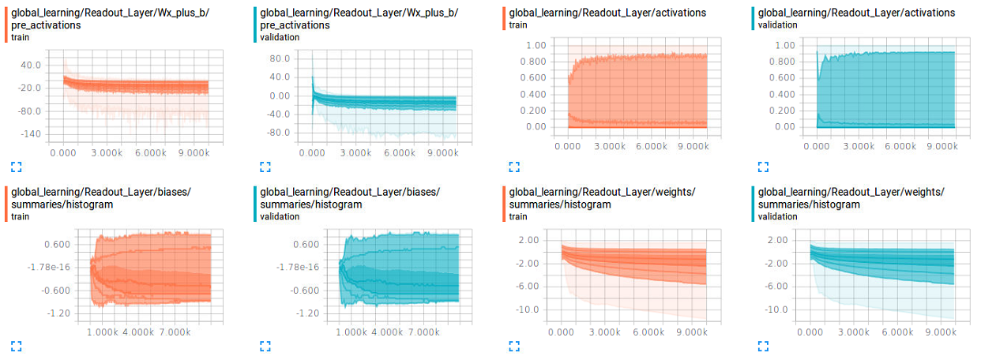

**Figure 33: MNIST SoftMax Regression Readout Layer Distributions of Global Network**

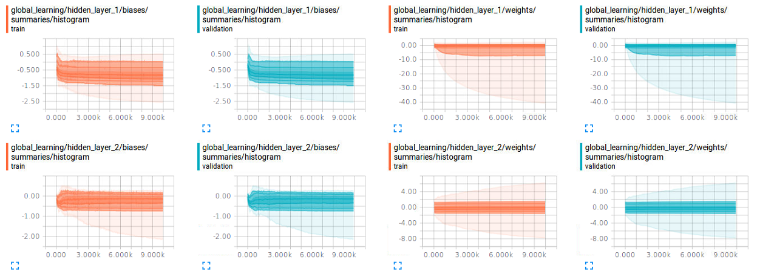

**Figure 34: MNIST SoftMax Regression Hidden Layer1 and 2 Distributions of Global Network**

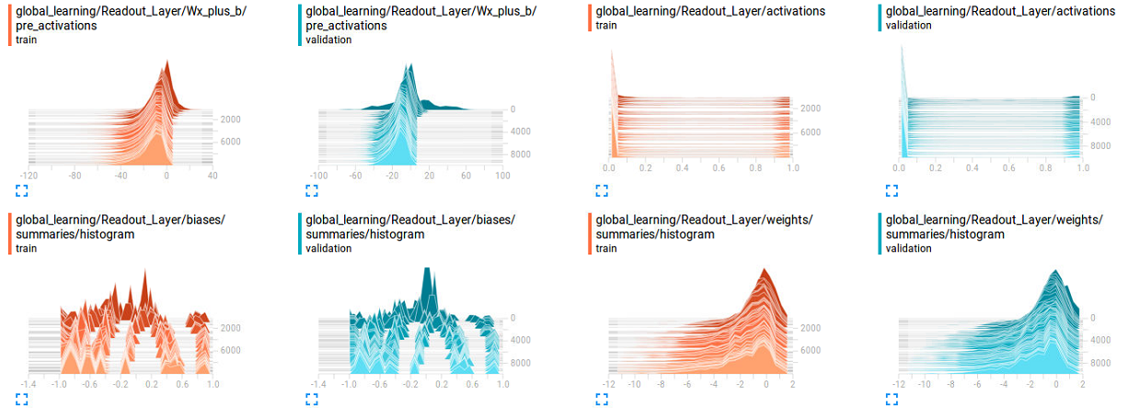

**Figure 35: MNIST SoftMax Regression Readout Layer Histograms of Global Network**

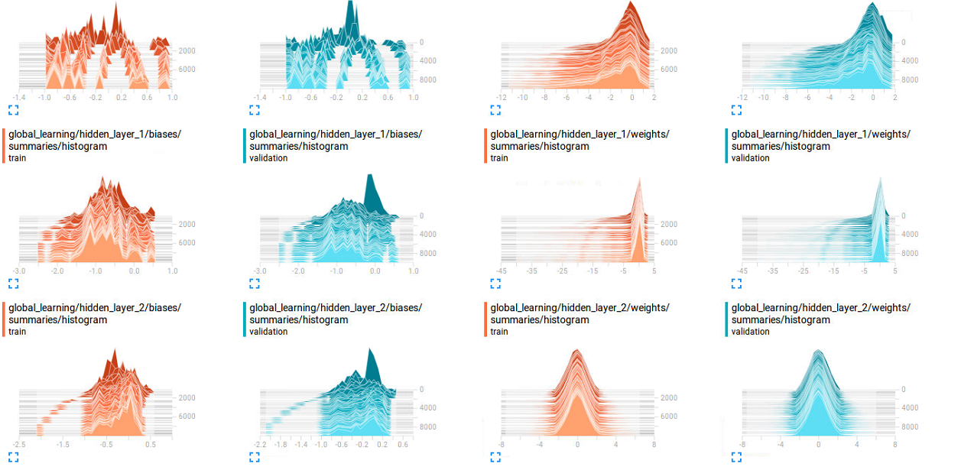

**Figure 36: MNIST SoftMax Regression Hidden Layer1 and 2 Histograms of Global Network**

* 1. **Summary**

The results from the experiments clearly indicate that presented approach significantly induces Distributed Learning and Incremental Learning, with a slight decrease in accuracy. Rather, we are interested in the tests which can tell us the performance of SigSpace compared to the state of art algorithms and methodologies in a quantitative and qualitative manner. There is still room for improvement in some of the components of the architecture and is open for discussion. The future work and improvements are discussed in detail in the next chapter.

CHAPTER 5

### CONCLUSION AND FUTURE WORK

**5.1 Conclusion**

### **This thesis presented a generalization technique or framework to build a scalable, distributed, incremental machine learning model. The generalization technique presented could scale well into smaller problems and optimal overall accuracy. Although there has been slight decrease in terms of overall accuracy, the generalization technique is efficient in terms of incremental learning for new data. Because of local learning, distributed learning is achieved which is not possible in most of the existing model designs.**

### **During inference stage, distributed computations can be used for faster response to client. Distributed inference is not always evident in the existing model designs. In the eco systems where new data is coming very often, the presented makes sure there are changes to part of the model. This together with the distributed inference, gives the computational efficiency which is not offered by existing original solutions. In the eco systems with different applications for same model, presented approach gives an efficient framework.**

**5.2 Limitations**

The approach presented in the thesis is dependent on local model predictions for unseen data, this issue needs to be addressed in more efficient manner. The global learning is a complex problem and presented evaluation used a feed forward network but more elegant network needs to be built. This global learning solution depends on the problem at hand and needs to designed for every specific problem.

**5.3 Future Work**

The architecture presented is evaluated on image classification, which can be extended to evaluate on a text classification model. Presented architecture can be improved by using a more appropriate method in selecting the proper local model group size and group set and appropriate global model weight initialization. Instead of predictions from the local model, intermediate layer activations can be provided as input to the global layers.

The proposed model can be extended to solve a more complex problem of building Multi-task Machine Learning model i.e., a model which can be used for multiple tasks. For e.g. a model which can do both image classification and speech recognition. Image classification and Speech classification separately in local learning and then combine those models in global learning which can understand both.

The presented model can be extended to build a dynamic machine learning model where global model can use different local models based on some context to deliver better predictions, this will be helpful in eco systems which heavily use same solution for different purposes.

REFERENCES

[1] "Machine learning." Wikipedia. March 27, 2017. Accessed April 01, 2017. https://en.wikipedia.org/wiki/Machine_learning.

[2] "Machine Learning - Stanford University." Coursera. Accessed April 01, 2017. <https://www.coursera.org/learn/machine-learning>.

[3] Hern, Alex. "Google says machine learning is the future. So I tried it myself." The Guardian. June 28, 2016. Accessed April 01, 2017. https://www.theguardian.com/technology/2016/jun/28/google-says-machine-learning-is-the-future-so-i-tried-it-myself.

[4] Marr, Bernard. "The Top 10 AI And Machine Learning Use Cases Everyone Should Know About." Forbes. September 30, 2016. Accessed April 01, 2017. https://www.forbes.com/sites/bernardmarr/2016/09/30/what-are-the-top-10-use-cases-for-machine-learning-and-ai/#7e532cb194c9.

[5] Jones, Stephen. "How the GPU Is Revolutionizing Machine Learning | NVIDIA Blog." The Official NVIDIA Blog. October 14, 2016. Accessed April 01, 2017. https://blogs.nvidia.com/blog/2015/12/10/machine-learning-gpu-facebook/.

[6] Mitchell, Tom. *Machine Learning*. McGraw-Hill, 1997

[7] "Supervised Learning." MathWorks. Accessed April 01, 2017. https://www.mathworks.com/discovery/supervised-learning.html.

[8] "Documentation." Introduction to Cluster Analysis - MATLAB & Simulink. Accessed April 01, 2017. https://www.mathworks.com/help/stats/introduction-to-cluster-analysis.html.

[9] "Unsupervised Feature Learning and Deep Learning Tutorial." Unsupervised Feature Learning and Deep Learning Tutorial. Accessed April 01, 2017. http://ufldl.stanford.edu/tutorial/supervised/MultiLayerNeuralNetworks/.

[10] "Multilayer perceptron." Wikipedia. March 23, 2017. Accessed April 01, 2017. https://en.wikipedia.org/wiki/Multilayer_perceptron.

[11] LeCun, Yann, Léon Bottou, Yoshua Bengio, and Patrick Haffner. "Gradient-based learning applied to document recognition." *Proceedings of the IEEE* 86, no. 11 (1998): 2278-2324.

[12] Krizhevsky, Alex, Ilya Sutskever, and Geoffrey E. Hinton. "Imagenet classification with deep convolutional neural networks." In *Advances in neural information processing systems*, pp. 1097-1105. 2012.

[13] "Logistic regression." Wikipedia. March 21, 2017. Accessed April 01, 2017. https://en.wikipedia.org/wiki/Logistic_regression.

[14] Mishkin, Dmytro, Nikolay Sergievskiy, and Jiri Matas. "Systematic evaluation of CNN advances on the ImageNet." *arXiv preprint arXiv:1606.02228* (2016).

[15] "TensorFlow." TensorFlow. Accessed April 01, 2017. https://www.tensorflow.org/.

[16] Abadi, Martín, Paul Barham, Jianmin Chen, Zhifeng Chen, Andy Davis, Jeffrey Dean, Matthieu Devin et al. "TensorFlow: A system for large-scale machine learning." In *Proceedings of the 12th USENIX Symposium on Operating Systems Design and Implementation (OSDI). Savannah, Georgia, USA*. 2016.

[17] Shen, Li, Gang Sun, Qingming Huang, Shuhui Wang, Zhouchen Lin, and Enhua Wu. "Multi-level discriminative dictionary learning with application to large scale image classification." *IEEE Transactions on Image Processing* 24, no. 10 (2015): 3109-3123.

[18] Wolpert, David H. "Stacked generalization." Neural networks 5, no. 2 (1992): 241-259

[19] Bengio, Yoshua, Frédéric Bastien, Arnaud Bergeron, Nicolas Boulanger-Lewandowski, Thomas M. Breuel, Youssouf Chherawala, Moustapha Cisse et al. "Deep Learners Benefit More from Out-of-Distribution Examples." In AISTATS, pp. 164-172. 2011.

[20] Ruder, Sebastian. "An overview of gradient descent optimization algorithms." arXiv preprint arXiv:1609.04747 (2016).

[21] Cadène, Rémi, Nicolas Thome, and Matthieu Cord. "Master's Thesis: Deep Learning for Visual Recognition." arXiv preprint arXiv:1610.05567 (2016).

[22] Vicapow. "Image Kernels explained visually." Explained Visually. Accessed April 01, 2017. http://setosa.io/ev/image-kernels/.

[23] LeCun, Yann, Yoshua Bengio, and Geoffrey Hinton. "Deep learning." Nature 521, no. 7553 (2015): 436-444.

[24] "Welcome to Deep Learning." Deep Learning. Accessed April 01, 2017. <http://deeplearning.net/>.

[25] "THE MNIST DATABASE." MNIST handwritten digit database, Yann LeCun, Corinna Cortes and Chris Burges. Accessed April 02, 2017. http://yann.lecun.com/exdb/mnist/.

[26] Mishkin, Dmytro, Nikolay Sergievskiy, and Jiri Matas. "Systematic evaluation of CNN advances on the ImageNet." arXiv preprint arXiv:1606.02228 (2016).

[27] Michael Nielsen. *Neural Networks and Deep Learning*. Determination Press, 2015.

[28] Simonyan, Karen, and Andrew Zisserman. "Very deep convolutional networks for large-scale image recognition." *arXiv preprint arXiv:1409.1556* (2014).

[29] Szegedy, Christian, Wei Liu, Yangqing Jia, Pierre Sermanet, Scott Reed, Dragomir Anguelov, Dumitru Erhan, Vincent Vanhoucke, and Andrew Rabinovich. "Going deeper with convolutions." In *Proceedings of the IEEE Conference on Computer Vision and Pattern Recognition*, pp. 1-9. 2015.

VITA

Manikanta Maddula completed her Bachelor’s degree in Electrical and Electronics Engineering from Amrita Vishwa Vidyapeetham in Coimbatore, India and then worked as an Application Developer in IBM India Pvt. Ltd. for 2 years. Mr. Manikanta Maddula started his Masters in computer Science at the University of Missouri-Kansas City (UMKC) in January 2017, with an emphasis on Data Sciences and he graduated in May 2017. While he was studying in UMKC, he has worked as Graduate Teaching Assistant for Big Data Apps and Analytics. Upon completion of her requirements for the Master’s Program, he plans to work as a Data Scientist/Machine Learning Engineer.